**Practical-9**

**Introduction to Collection Framework**

1)Create an Array List and perform following operations for that:

1. Add
2. Update
3. Delete
4. Convert in to array
5. Display using iterator()

**Code:-**

import java.util.ArrayList;

import java.util.Iterator;

public class Lab7_3

{

public static void main(String[] args)

{

ArrayList<String> cars = new ArrayList<String>();

System.out.println("ArrayList:");

cars.add("I-20");

cars.add("Dzire");

cars.add("Baleno");

cars.add("GrandI-10");

System.out.println(cars);

System.out.println("");

System.out.println("Arraylist After Removing One Element :");

cars.remove(3);

System.out.println("Arraylist now :" + cars);

System.out.println("");

cars.set( cars.indexOf("Baleno") , "MG-Hector");

System.out.println(cars);

System.out.println("");

Object[] objects = cars.toArray();

System.out.println("Array List into Array:");

for (Object obj : objects)

{

System.out.print(obj + " ");

}

System.out.println("");

System.out.println("");

Iterator <String> it = cars.iterator();

System.out.println("arrayList:");

while (it.hasNext())

{

System.out.println(it.next());

}

}

}

**Output:-**

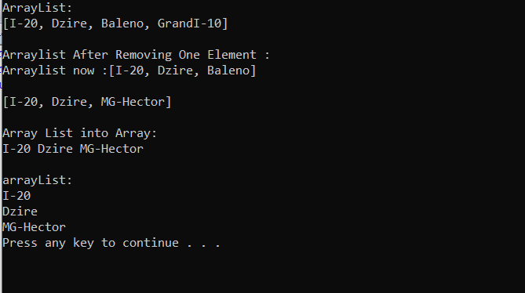

3)Create a LinkedList and perform following operations for that:

1. Insert at first
2. Insert at last
3. Delete from first
4. Delete from last
5. Update specific index node value
6. Remove from specific index
7. Display using iterator()

**Code:-**

import java.util.*;

import java.io.*;

public class Lab7_4

{

public static void main(String args[]){

String data;

Scanner s=new Scanner(System.in);

int choice;

LinkedList<String> ll=new LinkedList<String>();

while(true)

{

System.out.println("Press 1. For Add At First Posotion");

System.out.println("Press 2. For Add At Last Posotion");

System.out.println("Press 3. For Delete From First Posotion");

System.out.println("Press 4. For Delete From Last Posotion");

System.out.println("Press 5. For Update specific index node value");

System.out.println("Press 6. For Remove from specific index");

System.out.println("Press 7. For Display Using Iterator");

System.out.println("Press 8. For Exit");

System.out.print("Enter Choice:");

choice=s.nextInt();

switch(choice)

{

case 1:

System.out.println("Enter Data:");

data=s.next();

ll.addFirst(data);

break;

case 2:

System.out.println("Enter Data:");

data=s.next();

ll.addLast(data);

break;

case 3:

ll.removeFirst();

break;

case 4:

ll.removeLast();

break;

case 5:

String datau;

int index;

System.out.println("Enter Index:");

index=s.nextInt();

System.out.println("Enter Update Data:");

datau=s.next();

ll.set(index,datau);

break;

case 6:

int dindex;

System.out.println("Enter Index:");

dindex=s.nextInt();

ll.remove(dindex);

break;

case 7:

Iterator<String> iter= ll.iterator();

System.out.println("\nThe iterator values"+ " of list are: ");

while (iter.hasNext())

{

System.out.print(iter.next() + " \t\t");

}

System.out.println("");

break;

case 8:

return;

}

}

}

}

**Output:-**

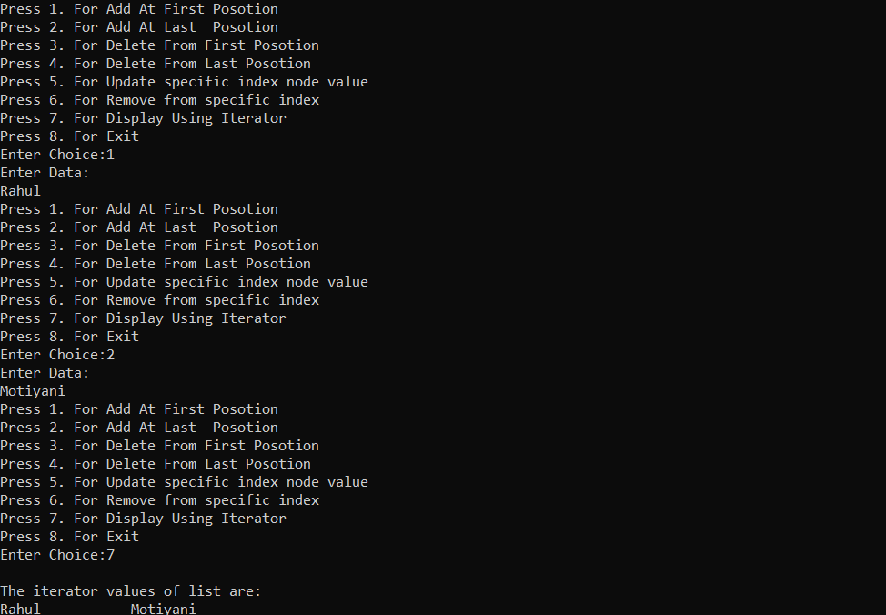

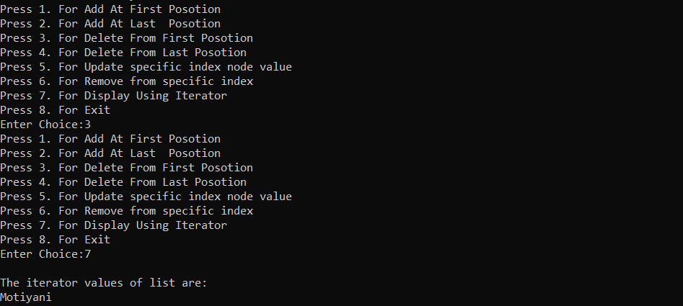

1. Create a HashSet and perform following operations for that:
2. Insert
3. Update
4. Delete
5. Display using iterator()

**Code:-**

import java.util.*;

public class Lab7_5

{

public static void main(String args[])

{

Scanner s=new Scanner(System.in);

int choice;

HashSet<Integer> hs=new HashSet<Integer>();

while(true)

{

System.out.println("Press 1. For Insert");

System.out.println("Press 2. For Update");

System.out.println("Press 3. For Delete");

System.out.println("Press 4. For Display Using Iterator");

System.out.println("Press 5. For Exit");

System.out.print("Enter Your Choice:");

choice=s.nextInt();

switch(choice)

{

case 1:

int data;

System.out.println("Enter Data:");

data=s.nextInt();

hs.add(data);

break;

case 2:

int d1,d2;

System.out.println("Enter old data:");

d1=s.nextInt();

System.out.println("Enter Update Data:");

d2=s.nextInt();

hs.remove(d1);

hs.add(d2);

break;

case 3:

int dindex;

System.out.println("Enter Data Value:");

dindex=s.nextInt();

hs.remove(dindex);

break;

case 4:

Iterator<Integer> iter= hs.iterator();

System.out.println("\nThe iterator values"+ " of set are: ");

while (iter.hasNext())

{

System.out.print(iter.next() + "\t\t");

}

System.out.println("");

break;

case 0:

return;

}

}

}

}

**Output:-**

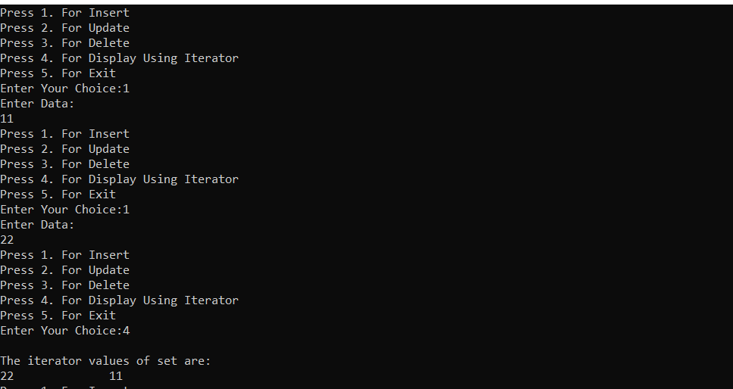

4)Create a HashMap and perform following operations for that:

1. Insert
2. Update
3. Delete
4. Display using iterator()

**Code:-**

import java.util.*;

import javax.lang.model.util.ElementScanner6;

public class Lab7_6

{

public static void main(String args[])

{

Scanner s=new Scanner(System.in);

int choice;

HashMap<Integer,String> hm=new HashMap<Integer,String>();

while(true)

{

System.out.println("Press 1. For Insert");

System.out.println("Press 2. For Update");

System.out.println("Press 3. For Delete");

System.out.println("Press 4. For Display Using Iterator");

System.out.println("Press 5. For Exit");

System.out.print("Enter Choice:");

choice=s.nextInt();

switch(choice)

{

case 1:

int index;

String data;

System.out.println("Enter Integer Index:");

index=s.nextInt();

System.out.println("Enter String Data:");

data=s.next();

hm.put(index,data);

break;

case 2:

int flag=0;

int uindex;

String udata;

System.out.println("Enter Integer Index:");

uindex=s.nextInt();

Iterator hmIte = hm.entrySet().iterator();

while (hmIte.hasNext())

{

Map.Entry mapElement = (Map.Entry)hmIte.next();

if(uindex==(int)mapElement.getKey())

flag=1;

}

if(flag==1)

{

System.out.println("Enter String Data:");

udata=s.next();

hm.put(uindex,udata);

}

else

{

System.out.println("Index Not found");

}

break;

case 3:

int dindex;

System.out.println("Enter Index Value:");

dindex=s.nextInt();

hm.remove(dindex);

break;

case 4:

Iterator hmIterator = hm.entrySet().iterator();

while (hmIterator.hasNext())

{

Map.Entry mapElement = (Map.Entry)hmIterator.next();

System.out.println(mapElement.getKey() + " : " + mapElement.getValue());

}

break;

case 0:

return;

}

}

}

}

**Output:-**

